A98-Eur-Greece-Figurine-Boar-Terracotta-5th Century BCE 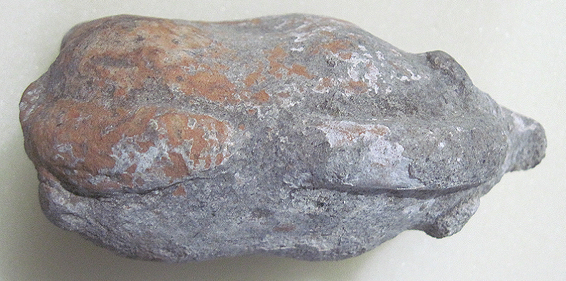 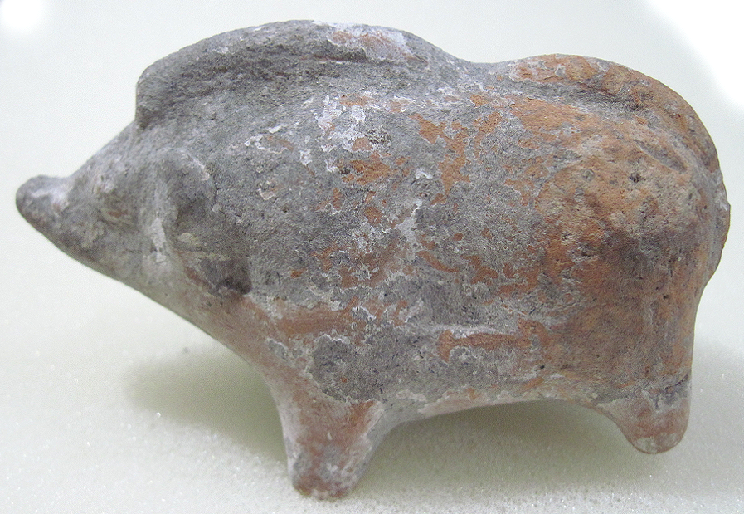

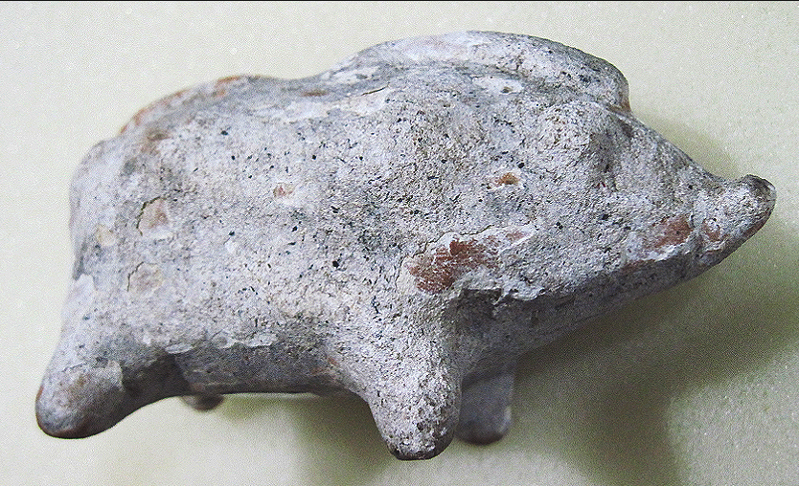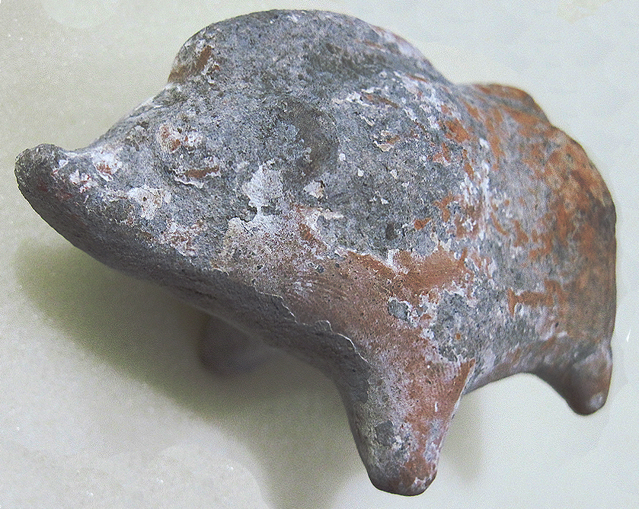

Figs. 1-4. Greek Terracotta Figurine of a Wild Boar, 5th Century BCE

Case no.: 4

Accession Number: A98

Formal Label: Greek Terracotta Figurine of a Wild Boar, 5th Century BCE

**Display Description:**

This solid, light-buff, terracotta figurine of a standing wild boar has molded ears, a pointed snout and a ridged back. Originally, the figurine was coated with a white kaolin slip, which has partly eroded.

The dark underworld connects the wild boar, an animal who lives in an underground burrow, and Demeter, who sought to retrieve her daughter from the underground cave at Eleusis where she was being held by Hades. Boar figurines were offered as votive objects to the goddess as companions in her search. Boar votive figurines have also been found buried with the dead to accompany them in their dark underworld abode.

**LC Classification:**  [DF 221 E4](http://catalog.lib.utexas.edu/search~S29?/cDF+221+E4+P73+2000/cdf++221+e4+p73+2000/-3,-1,,B/browse)

Date or Time Horizon: 5th century BCE

Geographical Area: Piraeus, Greece

**Map, GPS coordinates:**38°2'27"N 23°32'14"E

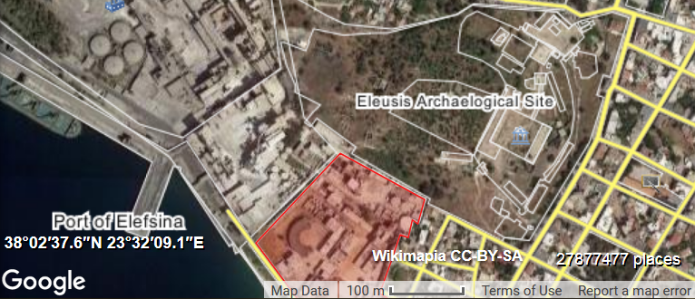

Cultural Affiliation: Greek

Media: terracotta, white kaolin slip

Dimensions: H 44 mm; L 90 mm

Weight: 104 g; 3 5/8 oz

Condition: original

Provenance: unknown

**Discussion:**

Two festivals involved the bestowing of boar figurines as votive offerings. The first is the Skirophoria, an annual Athenian festival organized by women after the harvest at threshing time on the 12th of Skirophorion (Σκιροφοριών) corresponding to June-July, the last Attic calendar month (Burkert, Walter. 1983 [1972]: 143-149). Skirophoria was proverbial for license in which the social order was inverted, the bonds of marriage suspended, women were left to band together and were free to leave the quarters where they were customarily confined. At Skiron on the road to Eleusis (where Skiros, an Eleusinian seer had been killed in battle with Athens) a ceremony was held in the sanctuary of Demeter and Persephone where votive objects like this boar figurine were offered to those who had fallen in battle.

The following festival, the Thesmophoria, celebrated human fertility and was observed only by women for three days in October (between the eleventh and the thirteenth), when the ground was being plowed for the autumn sowing of crops, which Homer associates with Demeter in the *Iliad* (V:500; XIII:322; XXI:76). The *Iliad* citations, which may date to the 12th to the 11th centuries BCE, correspond to the period before Ionia was settled in the 11th century BCE, when the Thesmophoria was thought to have been first observed throughout mainland Greece (Habash 1997). In this festival, in which only adult women could participate, on the third day of the Thesmophoria was *kalligeneia*, or "beautiful birth," when women beseeched the goddess Kalligeneia for their own fertility. At this point, boar figurines, like this one, were offered as votive gifts to Kalligeneia for a safe pregnancy and birth.

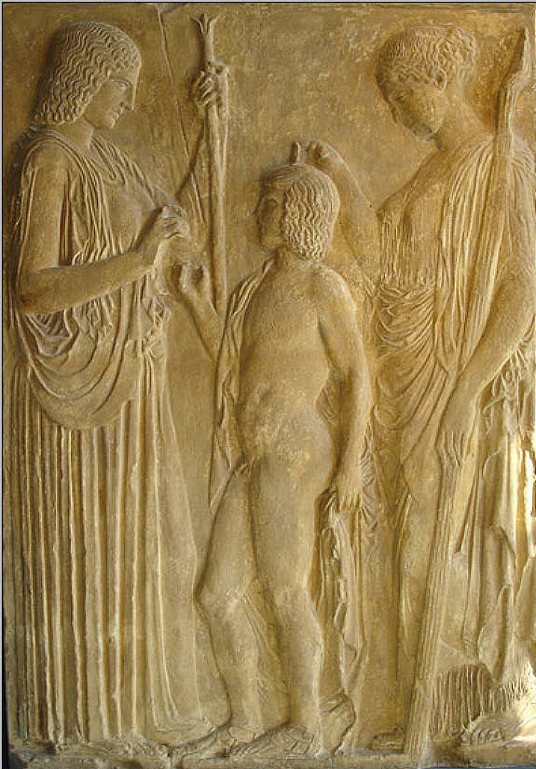 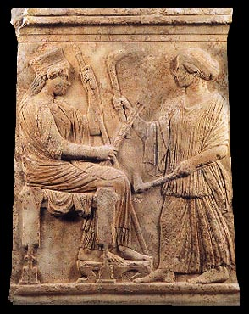

Fig. This Pentelic marble relief, which was found in Eleusis, represents Demeter at left clad in a peplos and holding a scepter in her left hand, offering ears of wheat to Triptolemos, son of Eleusinian king Keleos, to bestow on mankind. At right Persephone, clad in a mantle and holding a torch, blesses Triptolemos with her right hand. Copy of the relief from the 5th century BCE now in the National archaeological museum.

Fig. Relief representing Demeter and her daughter, c 480 BCE. Archaeological Museum, Eleusis 5085 (Preka-Alexandri 1997, p. 29, fig. 1).

**References:**

Burkert, Walter. 1983 [1972]. *Homo Necans: The anthropology of ancient Greek sacrificial ritual and myth.* Berkeley and Los Angeles: University of California Press.

Habash, Martha. 1997. "The Odd Thesmophoria of Aristophanes' *Thesmophoriazusae,*" *Greek, Roman, and Byzantine Studies*, **38** (1): 19-40.

Preka-Alexandri, K. 1997. Eleusis. Athens: Hellenic Ministry of Culture.